What percent of your IT services and tech support are provided in-house by your staff?
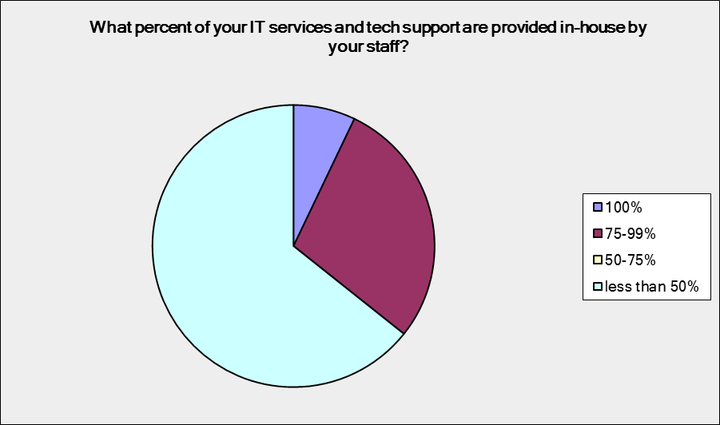
Budget = Less than $1 million:

Answer Options | Response Percent | Response Count
100% | 7.1% | 1
75-99% | 28.6% | 4
50-75% | 0.0% | 0
less than 50% | 64.3% | 9

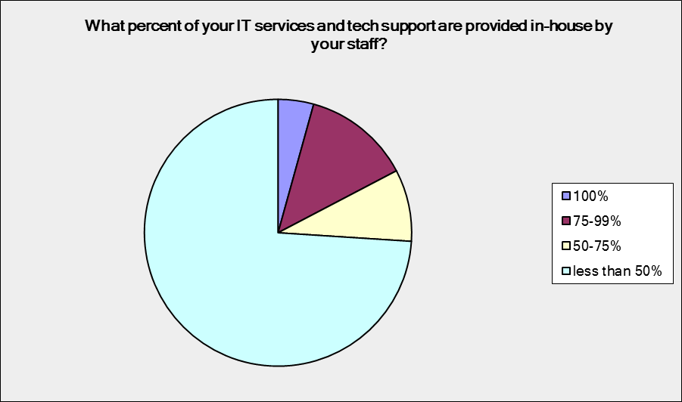
Budget = $1-5 million:

Answer Options | Response Percent | Response Count
100% | 4.3% | 1
75-99% | 13.0% | 3
50-75% | 8.7% | 2
less than 50% | 73.9% | 17

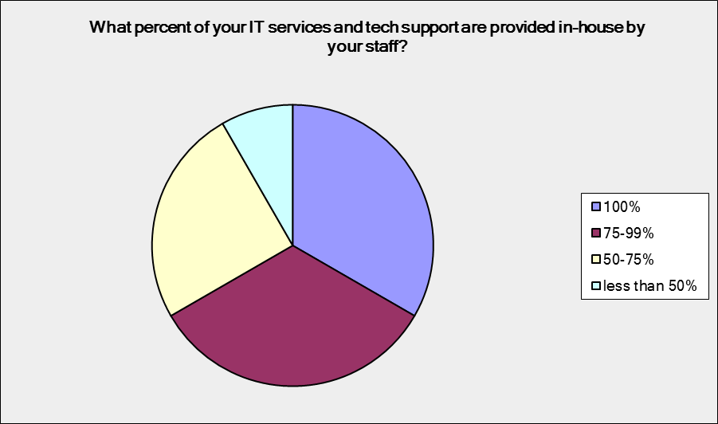
Budget = $5 million and above:

Answer Options | Response Percent | Response Count
100% | 33.3% | 4
75-99% | 33.3% | 4
50-75% | 25.0% | 3
less than 50% | 8.3% | 1

What case management software does your organization use?
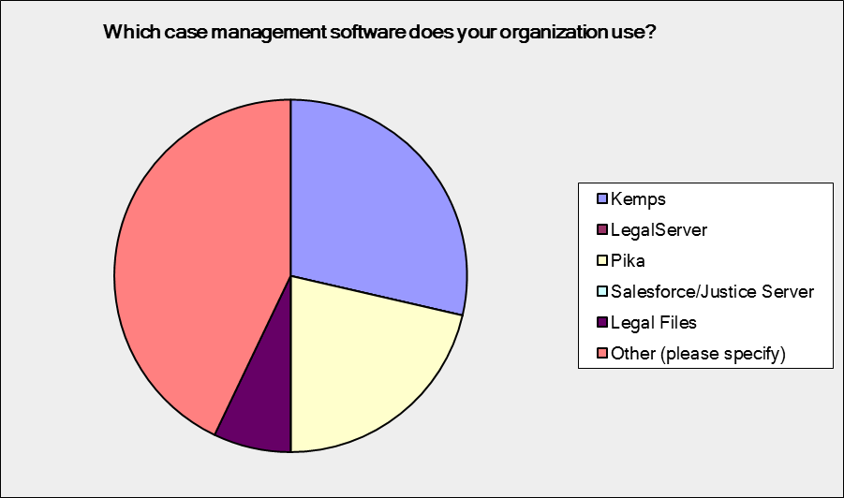
Budget = Less than $1 million:

Answer Options | Response Percent | Response Count
Kemps | 28.6% | 4
LegalServer | 0.0% | 0
Pika | 21.4% | 3
Salesforce/Justice Server | 0.0% | 0
Legal Files | 7.1% | 1
Other (please specify) | 42.9% | 6

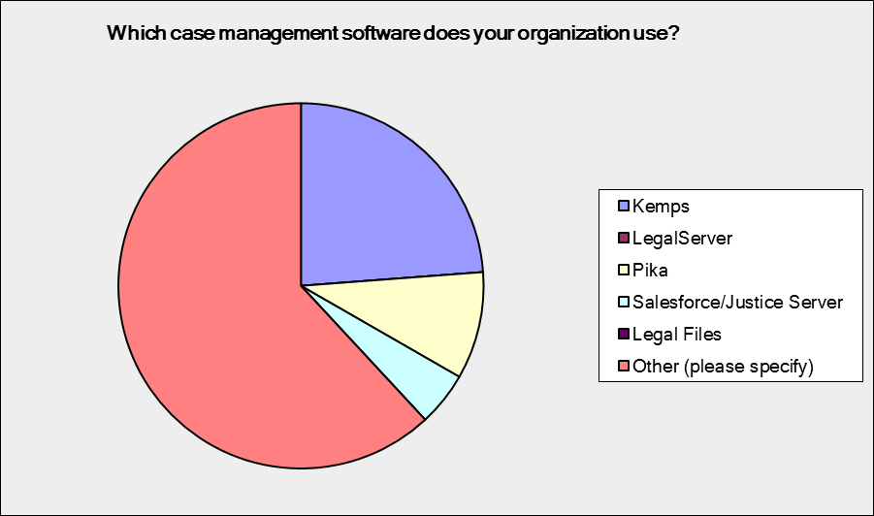
Budget = $1-5 million:
Answer Options | Response Percent | Response Count
Kemps | 23.8% | 5
LegalServer | 0.0% | 0
Pika | 9.5% | 2
Salesforce/Justice Server | 4.8% | 1
Legal Files | 0.0% | 0
Other (please specify) | 61.9% | 13

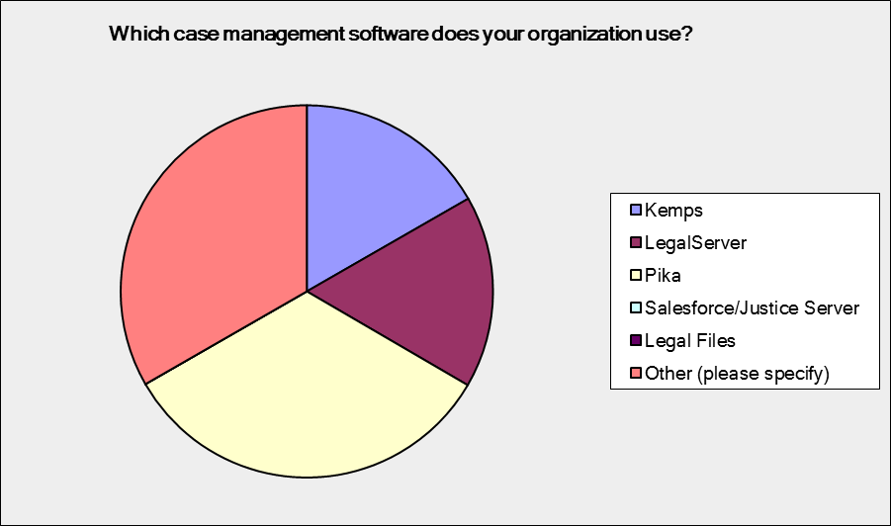
Budget = $5 million and above:
Answer Options | Response Percent | Response Count
Kemps | 16.7% | 2
LegalServer | 16.7% | 2
Pika | 33.3% | 4
Salesforce/Justice Server | 0.0% | 0
Legal Files | 0.0% | 0
Other (please specify) | 33.3% | 4

How satisfied is your organization with your case management software?
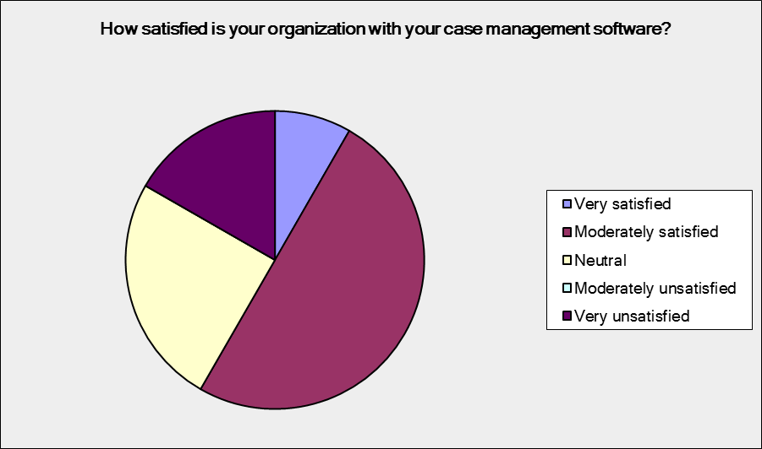
Budget = Less than $1 million:

Answer Options | Response Percent | Response Count
Very satisfied | 8.3% | 1
Moderately satisfied | 50.0% | 6
Neutral | 25.0% | 3
Moderately unsatisfied | 0.0% | 0
Very unsatisfied | 16.7% | 2

Budget = $1-5 million:
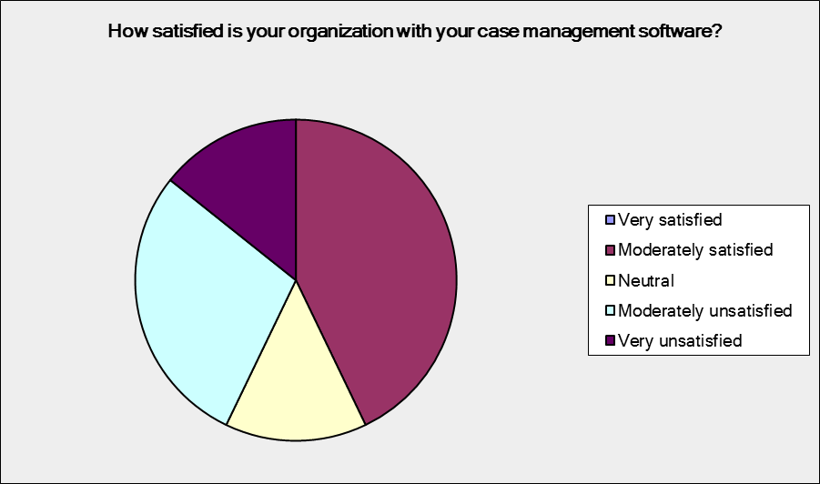
Answer Options | Response Percent | Response Count
Very satisfied | 0.0% | 0
Moderately satisfied | 42.9% | 9
Neutral | 14.3% | 3
Moderately unsatisfied | 28.6% | 6
Very unsatisfied | 14.3% | 3

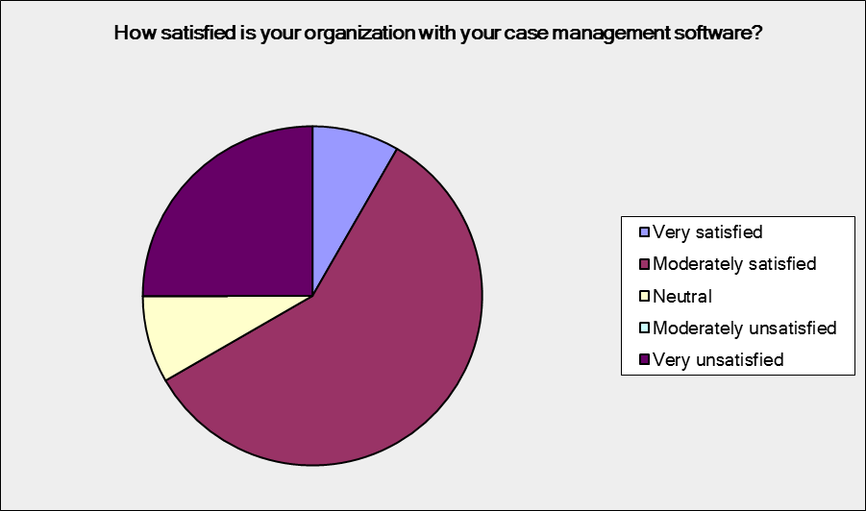
Budget = $5 million and above:
Answer Options | Response Percent | Response Count
Very satisfied | 8.3% | 1
Moderately satisfied | 58.3% | 7
Neutral | 8.3% | 1
Moderately unsatisfied | 0.0% | 0
Very unsatisfied | 25.0% | 3

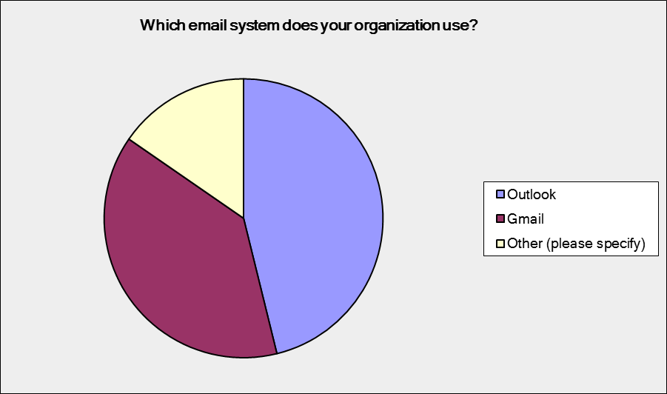
Which email system does your organization use?
Budget = Less than $1 million:

Answer Options | Response Percent | Response Count
Outlook | 46.2% | 6
Gmail | 38.5% | 5
Other (please specify) | 15.4% | 2

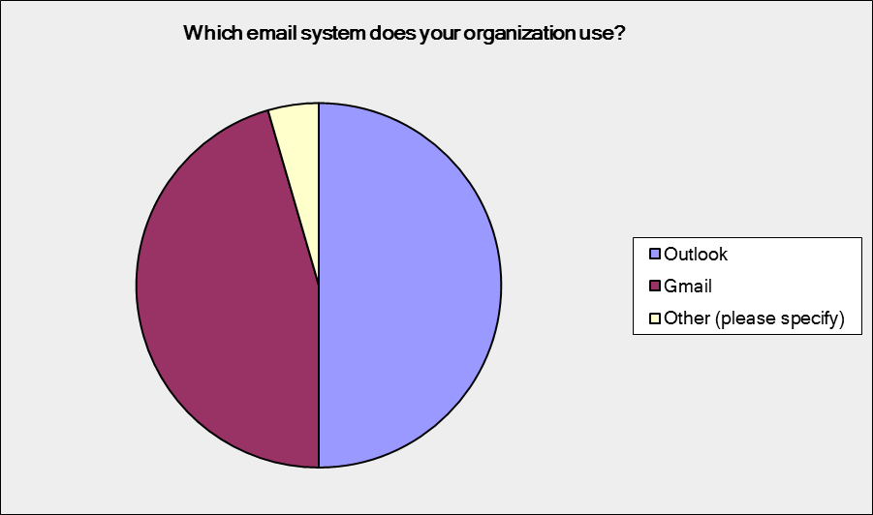
Budget = $1-5 million:

Answer Options | Response Percent | Response Count
Outlook | 50.0% | 11
Gmail | 45.5% | 10
Other (please specify) | 4.5% | 1

Budget = $5 million and above:
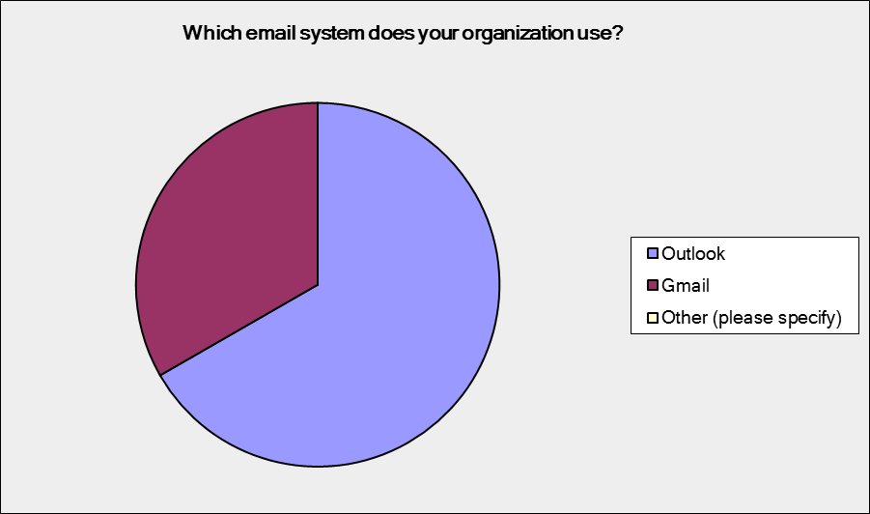
Answer Options | Response Percent | Response Count
Outlook | 66.7% | 8
Gmail | 33.3% | 4
Other (please specify) | 0.0% | 0

How does your organization store and/or share electronic files, including confidential or private information?
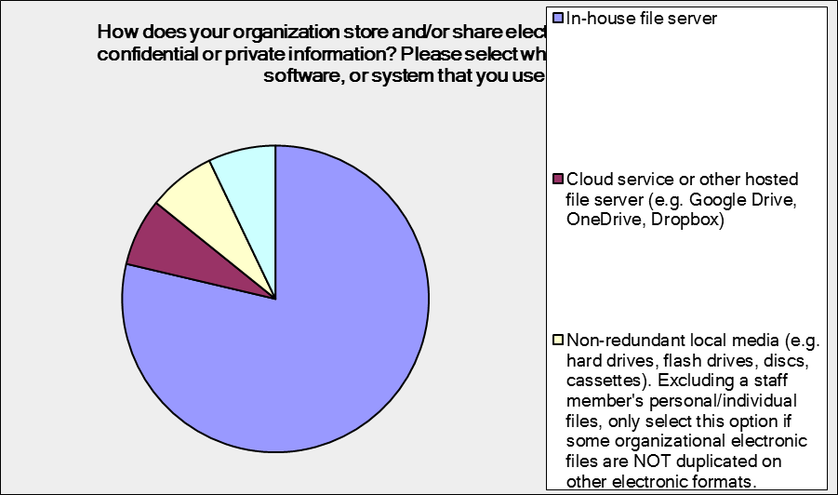
Budget = Less than $1 million:
Answer Options | Response Percent | Response Count
In-house file server | 78.6% | 11
Cloud service or other hosted file server | 7.1% | 1
Non-redundant local media  . | 7.1% | 1
Other (please specify) | 7.1% | 1

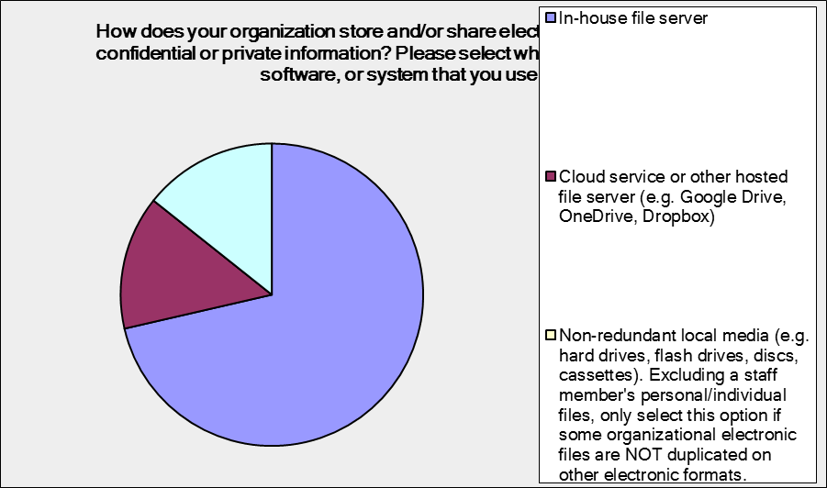
Budget = $1-5 million:
Answer Options | Response Percent | Response Count
In-house file server | 71.4% | 15
Cloud service or other hosted file server | 14.3% | 3
Non-redundant local media | 0.0% | 0
Other (please specify) | 14.3% | 3

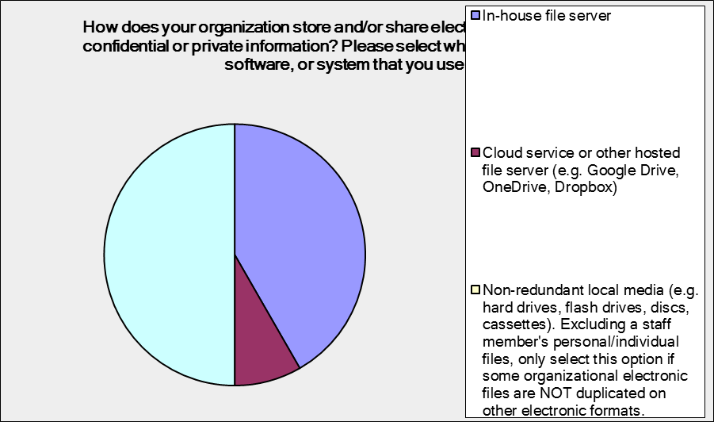
Budget = $5 million and above:
Answer Options | Response Percent | Response Count
In-house file server | 41.7% | 5
Cloud service or other hosted file server | 8.3% | 1
Non-redundant local media | 0.0% | 0
Other (please specify) | 50.0% | 6

