California Pleading Bank
Quick Start Guide

The Legal Aid Society of San Diego and Legal Aid Association of California are proud to announce the new beta site for California’s statewide pleading bank! This bank is possible due to a TIG (Technology Initiative Grant) from LSC. Open to attorneys at California’s IOLTA-funded legal services programs, the bank will help you share your work with others and download pleadings to modify and use for your work. LAAC staff will help troubleshoot as you navigate the new bank. Thanks to input from all IOLTA programs, we are confident this bank will save you time and help you serve your clients with greater efficiency!

- Go to https://capleadingbank.org. In the prompt, enter “capb.” Click “Create new account.”

- After you enter your information, you will receive a confirmation email once the administrator approves you as a user.

- Once you’re approved and logged in using your username and password, you will see the screen below. Here you can start browsing for pleadings, or use the “Search” feature at the top right.

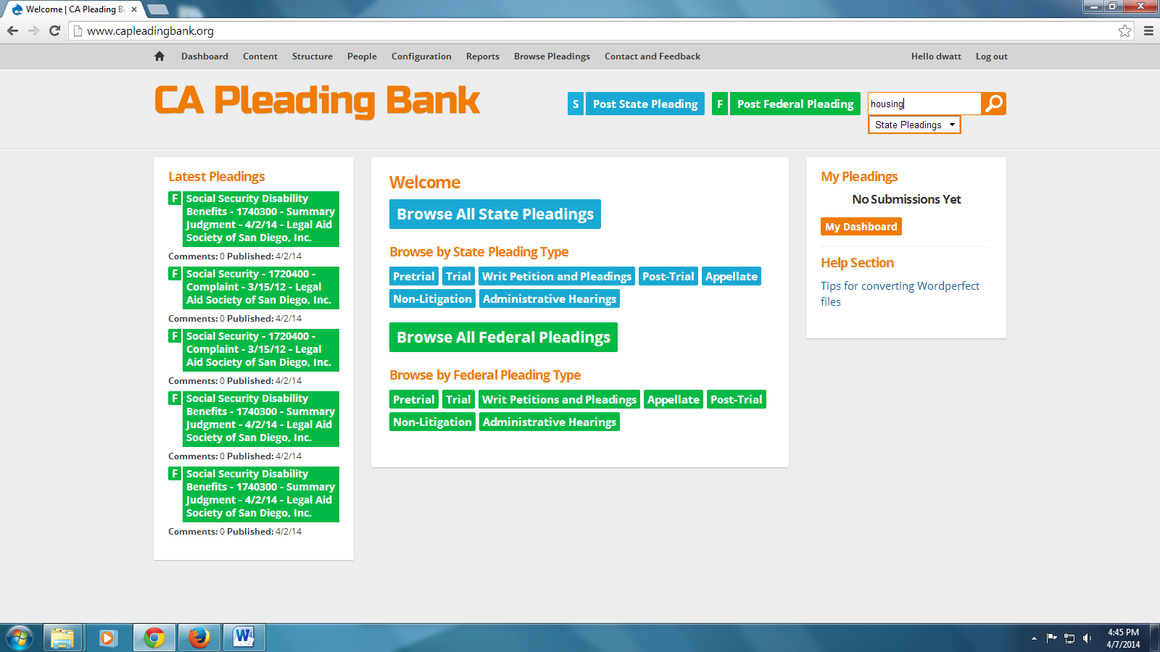
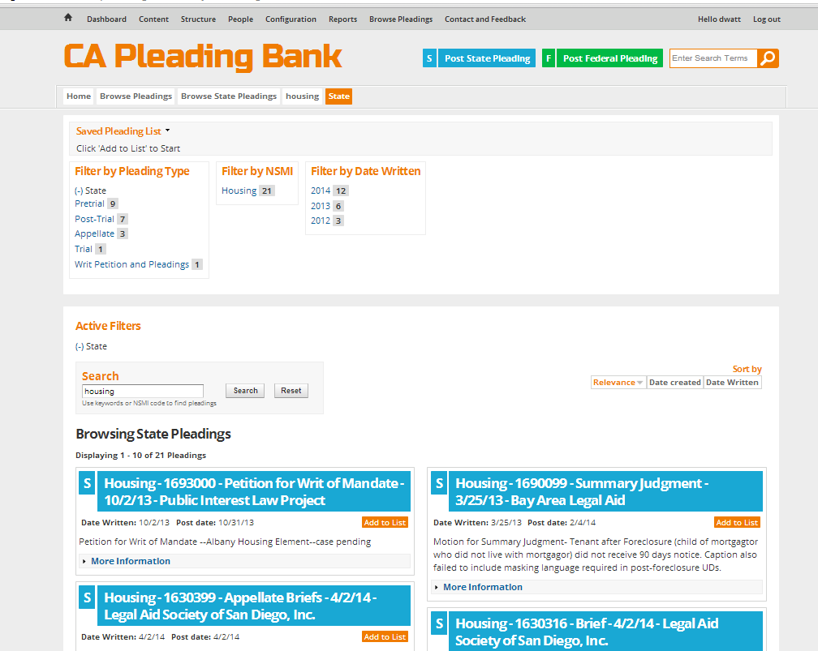
- This screen above follows the search for “housing.” You can further filter your search results by pleading type, NSMI or subject matter area, and date written.

- Click on “More Information” to learn more about the pleading and view or add comments.

- Once you join the pleading bank, we encourage you to post your pleadings!

For help and feedback, email capleadingbank@laaconline.org

