“The Unified Voice of Legal Services” | 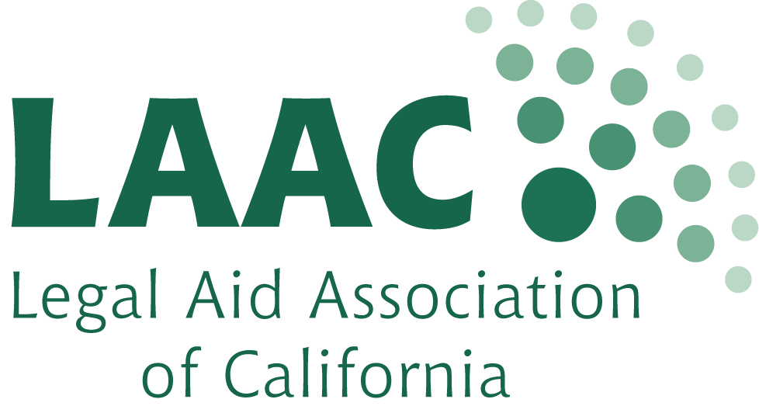
PRESS RELEASE

FOR IMMEDIATE RELEASE

CONTACT: Salena Copeland
415-834-0100 x 303
scopeland@laaconline.org

Legal Aid Association of California celebrates 30 years, honors California advocates

SAN FRANCISCO – The Legal Aid Association of California (LAAC) will celebrate 30 years as the membership organization for California’s legal services nonprofits this month in San Francisco.

To mark its anniversary, as well as honor this year’s Awards of Merit recipients, LAAC will host a celebration at 111 Minna Gallery on Friday, Jan. 31, 2014.

This year’s Awards of Merit recipients include Gerald McIntyre, directing attorney at the National Senior Citizens Law Center, and Adriana Melgoza, clinic manager at the Watsonville Law Center, based in Watsonville, Calif.

The LAAC Awards of Merit are the legal services community's opportunity to recognize the importance of legal services and to particularly honor a few of the many who have made contributions to the field during the last year.

The event will begin at 5 p.m., with the awards ceremony at 6 p.m. Tickets may be purchased by visiting www.LAAConline.org.

"LAAC is lucky to honor such amazing individuals as Jerry and Adriana at our Awards of Merit event,” said Salena Copeland, interim executive director at LAAC.

“It's advocates like them that make LAAC's work so rewarding and important."

Sponsors for the LAAC 30th Anniversary and Awards of Merit Celebration include Disability Rights California, Law Foundation of Silicon Valley, Legal Aid Society of San Mateo County, Legal Services of Northern California, National Immigration Law Center, National Senior Citizens Law Center, and Watsonville Law Center.

For more information, please contact Salena Copeland at (415) 834-0100 x 303.

For ticket information, contact Patrick Fodell at (415) 834-0100 x 312. Please note that 111 Minna Gallery has a 21+ age limit, and identification is required.

About Gerald McIntyre

At National Senior Citizens Law Center since 1993, McIntyre has, through his work, affected the lives of thousands of low-income Californians.

He recently led litigation efforts which returned more than $1.7 billion in Social Security and Supplemental Security Income (SSI) benefits to thousands of seniors and people with disabilities. His advocacy has led to the development of the Social Security Administration’s language access plan. As a national expert, McIntyre provides training to advocates throughout the country on various legal issues, including equal rights and access to benefits for lesbian, gay, bisexual and transgendered older adults.

“In addition to his high-profile advocacy work, Jerry works to expand access to the social safety net in countless small but important ways every day, as he provides unfailing and incisive support to legal services attorneys across the state,” said Kevin Prindiville, executive director of the National Senior Citizens Law Center.

“His intelligence, humility, generosity and dedication to those in need inspire us all. His effectiveness as an advocate for justice has had a life changing impact on hundreds of thousands.”

Since 1972, the National Senior Citizens Law Center has worked to promote the independence and well-being of low-income elderly and persons with disabilities, especially women, people of color, and other disadvantaged minorities. The National Senior Citizens Law Center’s principal mission is to protect the rights of low-income older adults.

About Adriana Melgoza

Melgoza works as clinic manager at Watsonville Law Center, where she started as a volunteer in 2009. She organizes legal services for low-income, primarily Spanish-speaking clients in the rural Central Coast. Her work to recruit both student and pro bono attorney volunteers has led to an increase of thousands of hours of volunteer service in legal aid on the Central Coast.

In addition to her work at Watsonville Law Center, Melgoza founded Unidos por un Corazón Inocente (United for an Innocent Heart), an organization that hosts support groups for Spanish-speaking, immigrant parents to share information about legal, medical, and personal resources. She also provides leadership in her role organizing an
annual event for parents of children with special needs, the Fiesta Familiar de la Costa Central.

“In all of Ms. Megloza’s work, she strives to transform deficits into opportunities, often with her own passion and endless capacity for hard work as the catalyst,” said Henry Martin, co-director of the Watsonville Law Center.

“Whether seeing the potential in the undergraduate student sons and daughters of legal aid clients, or the grassroots strength in immigrant families of autistic children, Ms. Melgoza is dedicated to increasing access to justice by working together with the communities being served.”

The mission of the Watsonville Law Center (WLC) is to provide low-income families and individuals equal access to the law by assisting them to understand, exercise, and enforce their rights.

About Legal Aid Association of California

Founded in 1984, the Legal Aid Association of California (“LAAC”) is a nonprofit organization created to ensure the effective delivery of legal services to low-income and underserved people and families throughout California. LAAC is the statewide membership organization of 87 nonprofit legal services organizations in the state. Our members provide high-quality legal services to our state’s most vulnerable populations.

These services to low-income and other underrepresented individuals form an essential safety net in California and often ensure that the programs’ clients have access to life’s basic necessities, such as food, safe and affordable housing, freedom from violence, health care, employment, economic self-sufficiency, and equal access to justice through the legal system.

# # #

